

SCHOOL OF INFORMATION TECHNOLOGY AND ENGINEERING
M.TECH SOFTWARE ENGINEERING

DIGITAL IMAGE PROCESSING[SWE-1010]

REVIEW-3 Report

FACE RECOGNITION AND ACKNOWLEDGEMENT

THROUGH TELEGRAM

SUBMITTED TO

FACULTY-Prof LAKSMI PRIYA

SlOT: E2+TE2

BY

D.Harish Kumar 16MIS0245
Felin Jonathan.M 16MIS0098

1


ABSTRACT

The objective of this project is to implement a face recognition system which first detects the face and then identifies the particular person by comparing the detected face with image database. It will help to maintain a strong security in that environment.

In general, we use CCTV cameras for the safety purpose. But we get to know or see it, if something goes wrong. In this project, whether its known or unknown person, whoever visits or tries to enter the house their information and captured image is passed to the owner at that instant via telegram.

Introduction

Face recognition is one of the most successful application of image analysis. It received significant attention especially during the past few years. Face detection and recognition is challenging due to the Wide variety of faces and the complexity of noises and image backgrounds. It is one of the key areas under research and has number of applications and uses.

Real time face recognition is part of biometric fields. Biometric is where a computer recognizes a human through a physical trait. In Face recognition computer recognizes a human by facial characteristics. Today we face major security issues. We need several specially trained personnel or people to attain the desired security. These people making mistakes might affect the level of security.

Solution to this problem is a Face Recognition Security System, which can detect intruders and help in minimizing human error. In this project we are going to build a face recognition security system, which helps us to get to know who visited from the place, from us being anywhere through telegram acknowledgement.

3. Literature Review

Technique Name |  | Technique |  |  |  |  | Advantage |  |  |  |  |  |  | Disadvantage
 |  | Description
Face Recognition |  | Since |  | one | of | theSince |  |  | one |  | of |  | the | The |  |  |  | enormous
from | Video | major applications of |  |  |  |  | major applications of |  |  |  |  |  |  | abundance
Sequences |  | face | recognition |  |  | isface |  |  | recognition |  |  |  | is | of data |  |  | empowers |  | the
 |  | surveillance |  |  |  | forsurveillance |  |  |  |  |  |  | for | system |  | to | choose |  | the
Authors:Qianqian |  | security |  | purposes,security |  |  |  |  |  |  | purposes, |  |  | frame with the
Zhao ,Hualong Cai |  | which |  | involves |  | real-which |  |  |  | involves |  | real- |  | best possible image and
 |  | time | recognition |  |  | oftime |  |  | recognition |  |  |  | of | discard
 |  | faces | from an |  | image |  | faces |  | from an image |  |  |  |  | less satisfactory ones
 |  | sequence captured by |  |  |  |  | sequence captured by |  |  |  |  |  |  | Video provides temporal
 |  | a video camera. |  |  |  |  | a | video |  | camera, |  |  | a | continuity |  |  |  | , | so
 |  | A video-based face |  |  |  |  | significant amount of |  |  |  |  |  |  | classification
 |  | recognition |  |  |  |  | research |  |  | has |  | been |  | information from several
 |  | system |  |  | typicallydirected |  |  |  |  | towards |  | this |  | frames can be combined
 |  | consists |  |  |  |  | area in recent years. |  |  |  |  |  |  | to
 |  | of three modules: one |  |  |  |  | Most of these systems |  |  |  |  |  |  | improve |  |  | recognition
 |  | for detecting the face; |  |  |  |  | choose |  |  |  |  |  |  | performance.. |  |  |  | Dynamic
 |  | a second one |  |  |  |  | a | few good |  |  | frames |  |  | schemes also have
 |  | for tracking it; and a |  |  |  |  | and then |  |  |  |  |  |  | an edge over static ones
 |  | third |  | one |  | forapply |  |  | one |  | of |  | the | when |  | it | comes |  | to
 |  | recognizing it. |  |  |  |  | recognition |  |  |  |  |  |  | detecting the
 |  |  |  |  |  |  | techniques |  |  |  |  |  | for | face | in | a scene, since
 |  |  |  |  |  |  | intensity |  |  |  |  |  |  | these | schemes |  |  | can | use
 |  |  |  |  |  |  | images |  |  | to | those |  |  | motion to
 |  |  |  |  |  |  | frames |  |  | in | order |  | to | segment |  |  | a | moving
 |  |  |  |  |  |  | identify the individual |  |  |  |  |  |  | person’s face
Eigenface |  | Based on Principal |  |  |  |  |  |  | Relatively |  |  |  |  | •Difficult |  |  | to | recognise
based Methods |  | Component |  |  |  |  |  |  | simple |  |  |  |  | Different
-PCA Algorithm |  | Analysis |  |  | (PCA |  |  |  | Fast |  |  |  |  | head pose
 |  | reduces |  | the |  |  |  |  | Robust |  |  |  |  | •Difficult |  |  | to | recognise
AUTHOR: |  | dimension of the |  |  |  |  |  |  | Work well with |  |  |  |  | Different
Anissa | Lintang | data)Create an image |  |  |  |  |  |  | high |  |  |  |  | alignment
 |  |  |  |  |  |  |  | 3


Ramadhani, | subspace (face | dimension. | •Difficult to recognise
Purnawarman | space) which best |  | Different
Musa, Eri Prasetyo | discriminates |  | facial expression
Wibowo | between faces like
 | faces occupy near
 | points in face
 | space. It Compare
 | two faces by
 | projecting the
 | images into faces
 | speed and
 | measuring
 | the distance between
 | them.

Invariant Feature |  | Feature-invariant |  |  |  |  | •Find invariant
Method |  | methods |  |  |  |  | features of a |  | •Like | Eigenface |  | based
 |  | that | try |  | to | find face anyway of |  |  | method It is difficult to
Authors:Imad |  | invariant features of |  |  |  |  | it‟s angle or |  | recognise a face |  |  | which
Mohamed |  | a face |  | despite |  | its position |  |  | having different Facial
Ouloul*, | Karim angle |  |  | or | position. •Features of the |  |  |  | expression. |  | So, | more
Afdel**, Abdellah |  | Facial |  |  | recognition facelike |  |  | Mouth, dataset |  | with | different
Amghar*, | Zakaria utilizes |  |  |  | distinctive Nose, |  |  |  | Eye, facial | expression |  |  | is
Moutakki* |  | features of the face – |  |  |  |  | Cheekbones, |  | required.
 |  | including: |  |  | distinct Chin,Lips, |  |  | Forehead,
 |  | micro | elements |  |  | like: Ears are extracted and •In other words |  |  |  |  |  | a static
 |  | Mouth, |  | Nose, |  | Eye, enrolled for |  |  | picture | can | be | easily
 |  | Cheekbones, |  |  |  | Chin, recognition |  |  | recognised by
 |  | Lips, Forehead, |  |  |  |  |  |  | Feature invariant method
 |  | Ears,Upper |  |  | outlines
 |  | of the eye sockets, the
 |  | areas
 |  | surrounding |  |  |  | the
 |  | cheekbones, the sides
 |  | of the mouth, and the
 |  | location |  | of | the nose

4


and eyes. The

distance between the

eyes, the length of the

nose and the angle of

the jaw.

Holistic | •Holistic |  | approaches •The |  |  | main advantage • Most of these
Approach | attempt |  | to | identify of |  | the |  | holistic approaches start out with
for | Face faces | using |  |  | global approaches is that |  |  |  | the basic assumption that
Recognition | representations, |  |  |  | i.e., they | do | not | destroy all |  | the pixels |  |  | in the
 | descriptions based on any |  |  |  |  |  | of |  | the image |  | are |  | equally
Authors: Soumya the entire |  |  |  |  | information |  |  | in | the important. Conse-
Kanti Das | , and image rather than on images by |  |  |  |  |  |  |  | quently, these techniques
Lutfa Akte | local | features |  | of the concentrating on only are |  |  |  |  |  |  | not |  | only
 | face. These |  |  |  | limited |  | regions |  | or computationally
 | schemes |  | can |  | be points of interest. |  |  |  | expensive |  |  | but | require | a
 | subdivided |  | into |  | two |  |  |  | high |  |  | degree |  | of
 | groups: statistical and |  |  |  |  |  |  |  | correlation |  |  | between the
 | AI approaches. |  |  |  |  |  |  |  | test and training images
 |  |  |  |  |  |  |  |  | • | Do |  | not | perform
 | •In | the | simplest |  |  |  |  |  | effectively |  |  | under large
 | version of the holistic |  |  |  |  |  |  |  | variations |  |  | in pose, scale
 | approaches, the |  |  |  |  |  |  |  | and illumination, etc.
 | image | is | represented
 | as a 2D array of
 | intensity values and
 | recognition |  |  |  | is
 | performed |  | by |  | direct
 | correlation
 | comparisons
 | between |  | the |  | input
 | face and all the other
 | faces in the
 | database.
 |  |  |  |  | 5

Infra-red | based | The thermal infra-red |  |  |  |  | •It improves | face
technique |  | imagery is insensitive |  |  |  |  | recognition |  | •It is subjected to a low
Authors: |  | to variations |  |  |  |  | performances. |  | resolution and high noise
Authors: | Jinwoo | in | lighting |  |  | which |  |  | in the
Kang, | Amol | makes such image to |  |  |  |  |  |  | images.
Borkar; Angelique |  | be used for detecting |  |  |  |  |  |  | •There is lack of widely
Yeung, | Nancy | and |  | recognizing |  |  |  |  | available | data sets | of
Nong, | Mark | faces. |  | When |  | using |  |  | infra-red.
Smith, | Monson | infra-red the |  |  | images |  |  |  | •There is | possibility | of
Hayes |  | vein |  |  |  |  |  |  | occlusion in part of face
 |  | and | tissues |  | structure |  |  |  | with eye
 |  | which |  | are | unique in |  |  |  | glasses
 |  | each individual yield
 |  | a good results |  |  |  | when
 |  | applied |  | to |  | these
 |  | images.


Requirements

Hardware requirements:

4gb ram

i5processor Webcam

Software requirements:

windows 10 or Linux

Programming language: python

Packages: opencv, numpy

Database: sqlite3

Invention details

Objects of the invention

Before a face is being recognized, face is located using viola jones algorithm. After face detection, face recognition is done by Local binary patterns histogram(LBPH) algorithm. Histograms are generated for two images and compared, and the image with the closest histogram is returned. Based on the confidence the image is accepted or rejected.

Summary of Invention

The present invention observes and evaluates two or three people. The invention is always set on such that even without the person’s knowledge their image is captured and sent to the owner through telegram application. If the person’s details is already saved in the database then their details is sent along with the image. Through this invention the owner will be informed as and when someone enters the house or trespasser trying to enter house. So ,the invention gives security to the people in apartments.

9

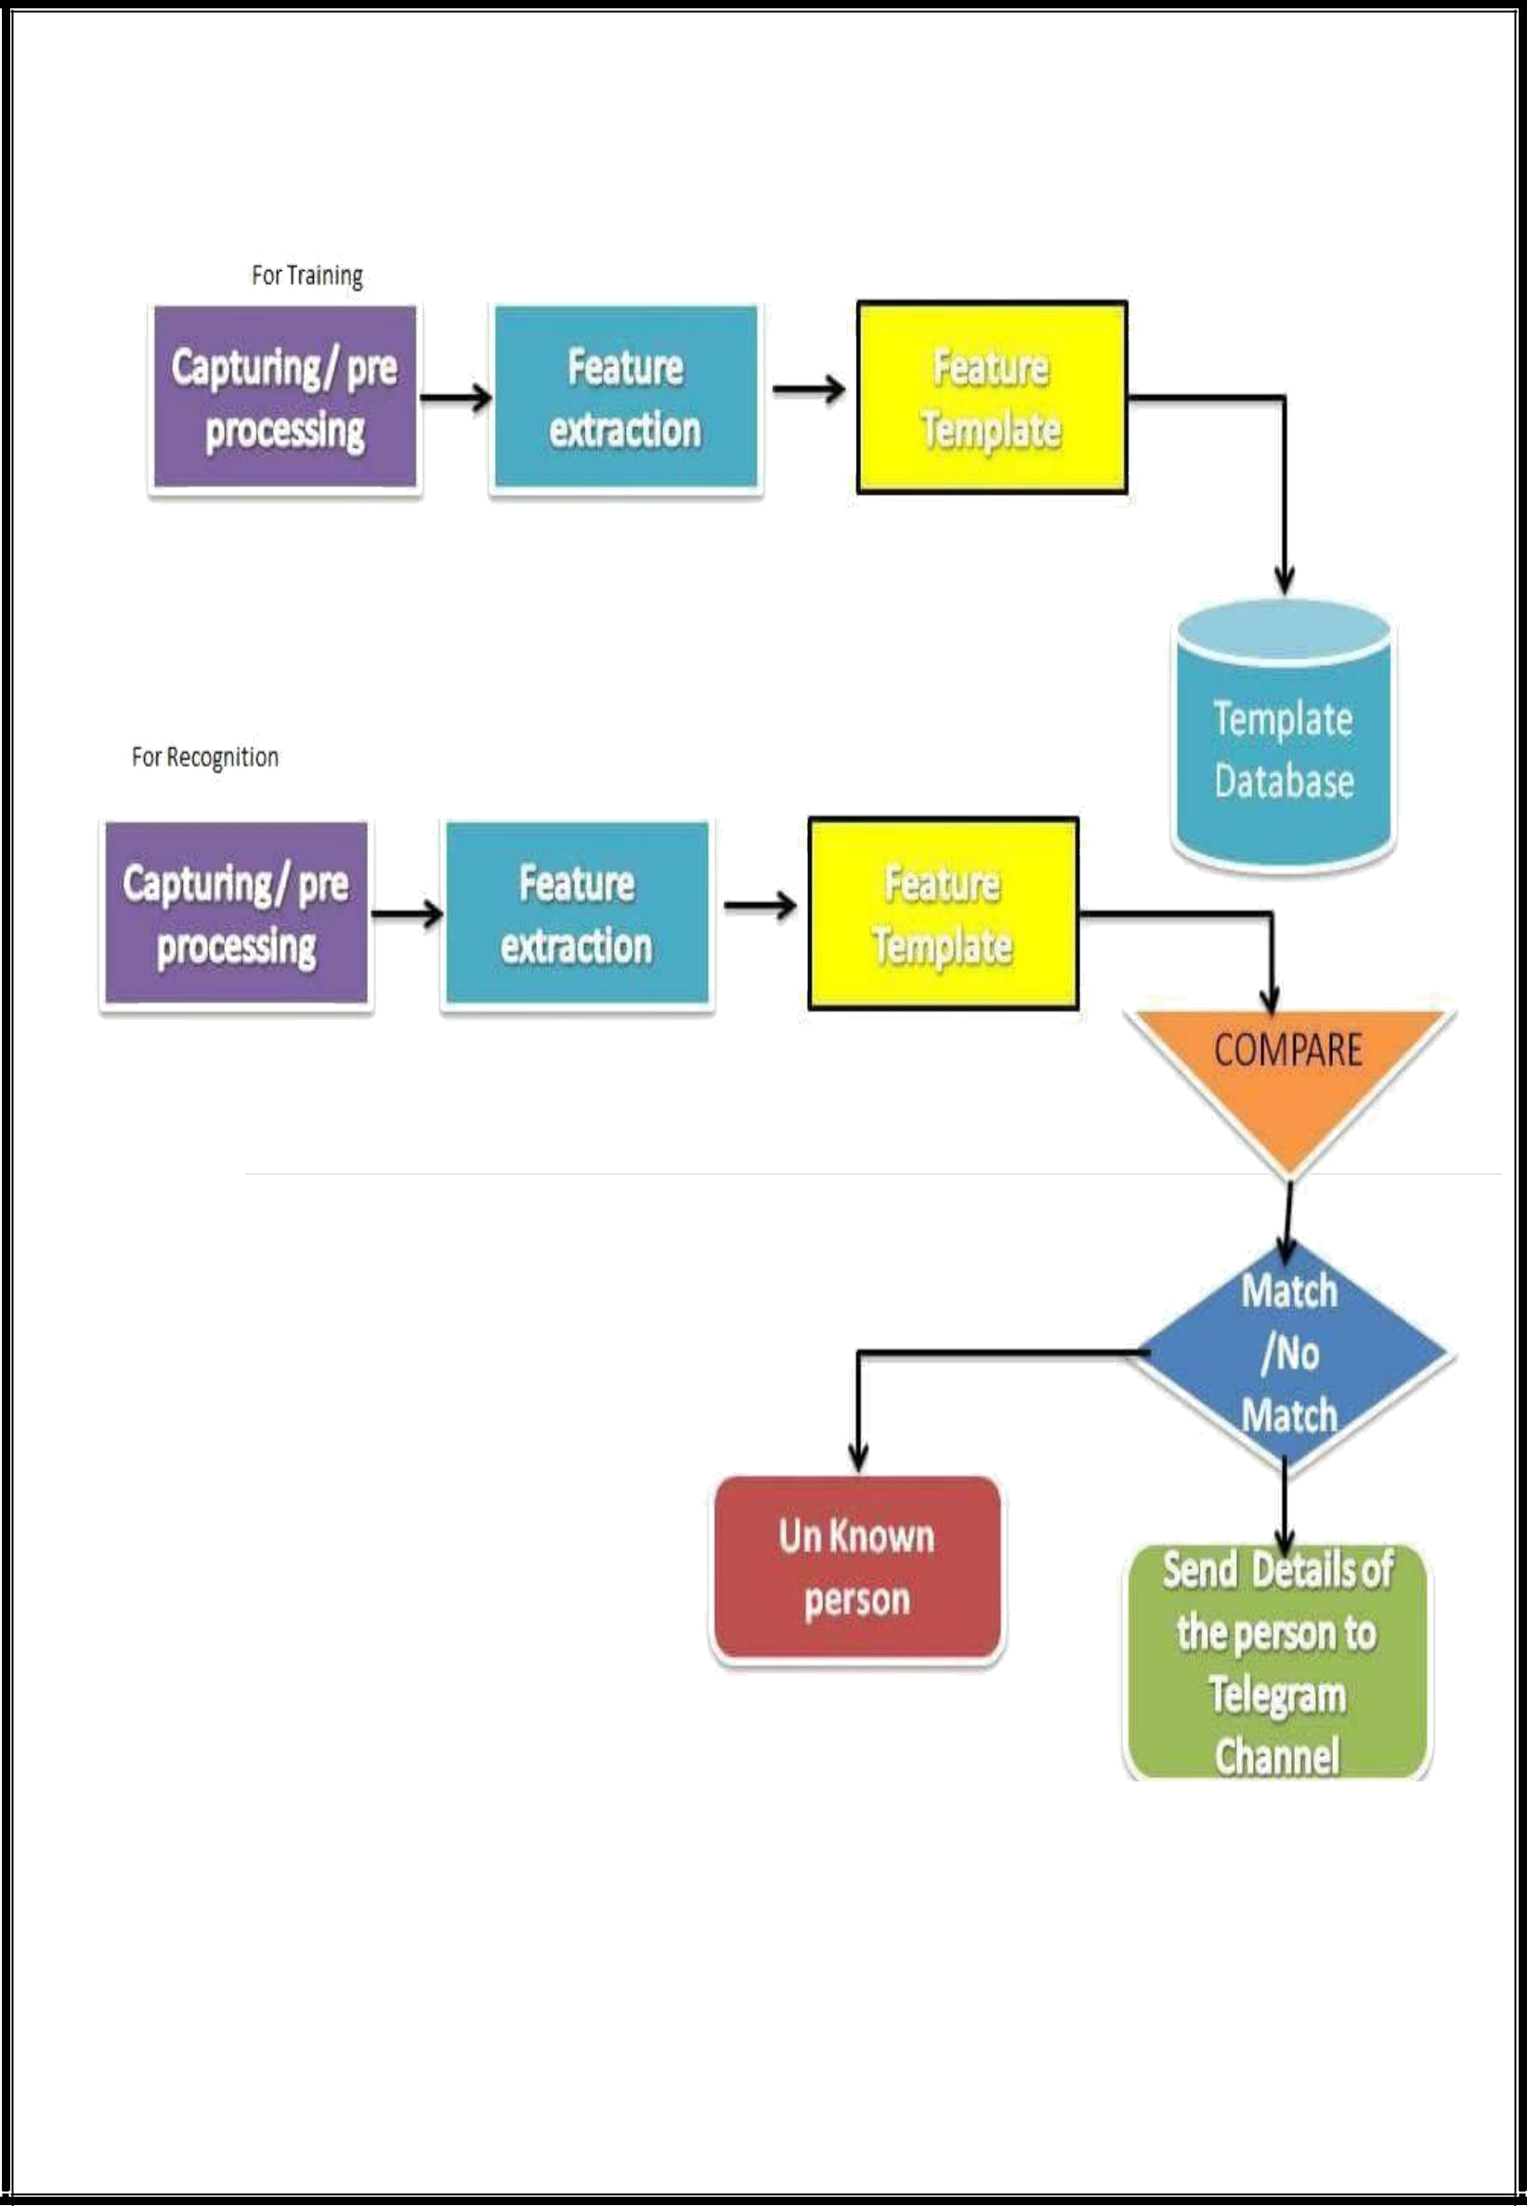
Architecture of project

10


Experimental Description

The image is captured along with the id and the person’s name and relationship and stored in database. Face is captured by using viola jones algorithm, which is used to detect the face region in the image.

After the face is detected LBPH algorithm is used to compare and recognize the face. It uses 4 parameters:

Radius: the radius is used to build the circular local binary pattern and represents the radius around the central pixel. It is usually set to 1.

Neighbors: the number of sample points to build the circular local binary pattern. It is usually set to 8.

Grid X: the number of cells in the horizontal direction. The more cells, the finer the grid, the higher the dimensionality of the resulting feature vector. It is usually set to 8.

Grid Y: the number of cells in the vertical direction. The more cells, the finer the grid, the higher the dimensionality of the resulting feature vector. It is usually set to 8.

Training the Algorithm :

To train the algorithm we need to use a dataset with the facial images of the people we want to recognize. We set an ID, name and relationship for each image, the algorithm will use this information to recognize an input image and give an output. Images of the same person must have the same ID.

Applying the LBP operation :

The first computational step of the LBPH is to create an intermediate image that describes the original image in a better way, by highlighting the facial characteristics. The algorithm uses a concept of a sliding window, based on the parameters radius and neighbors.

The image below shows this procedure:
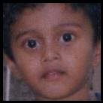
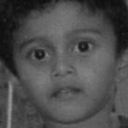

-------------------------------------->

Captured Image Greyscale

Image Image
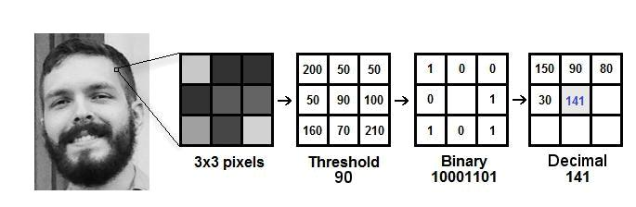

Image is represented as a 3x3 matrix containing the intensity of each pixel (0~255).

12

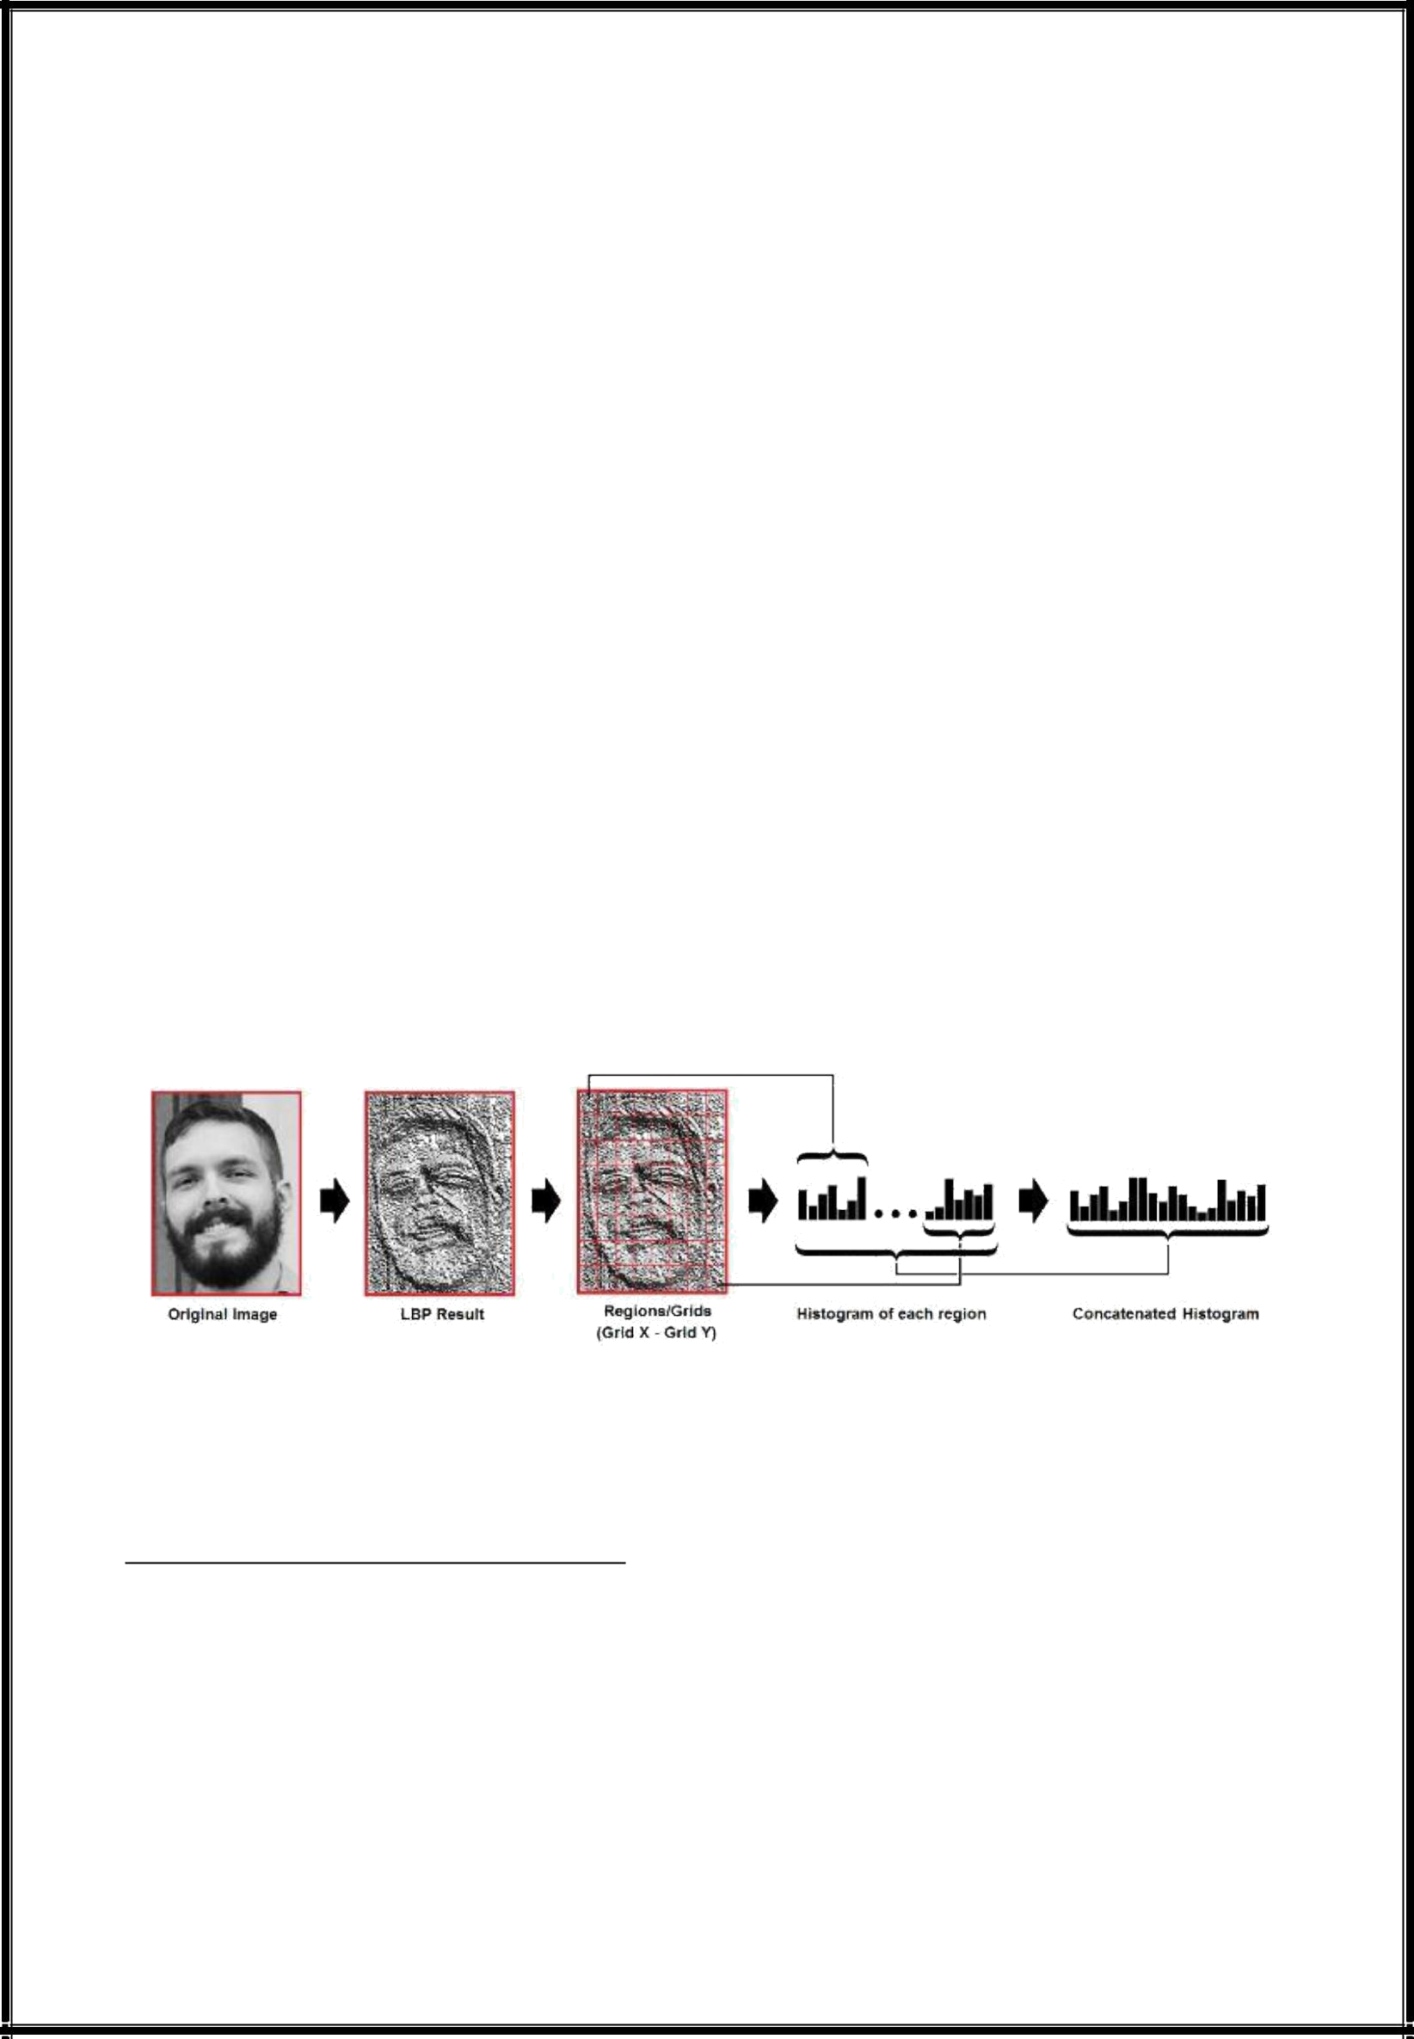
Then, the central value of the matrix is used as the threshold.

This value will be used to define the new values from the 8 neighbors.

For each neighbor of the central value (threshold), a new binary value is set. 1 is set for values equal or higher than the threshold and 0 for values lower than the threshold.

Now, the matrix will contain only binary values (ignoring the central value). We need to concatenate each binary value from each position from the matrix line by line into a new binary value.

Binary value is converted to a decimal value and set it to the central value of the matrix, which is actually a pixel from the original image.

At the end of this LBP procedure , we have a new image which represents better the characteristics of the original image.

Extracting the Histograms :

Now, using the image generated in the last step of LBPH, we can use the Grid X and Grid Y parameters to divide the image into multiple grids, as can be seen in the following image:

Based on the image above, we can extract the histogram of each region.

Performing the face recognition :

In this step, the algorithm is already trained. Each histogram created is used to represent each image from the training dataset. So, given an input image, we perform the steps again for this new image and creates a histogram which represents the image.

13


So to find the image that matches the input image we just need to compare two histograms and return the image with the closest histogram.

We can use various approaches like Euclidean distance to compare the histograms.

So the algorithm output is the ID from the image with the closest histogram. The algorithm should also return the calculated distance, which can be used as a ‘confidence’ measurement. As lower confidences are better because it means the distance between the two histograms is closer.

We can then use a threshold and the ‘confidence’ to automatically estimate if the algorithm has correctly recognized the image. We can assume that the algorithm has successfully recognized if the confidence is lower than the threshold defined.

Working Scenario

The camera in home captures the individual and train the images by the system and saved in database. If the same person in database came to home the persons face is detected by the camera and send the relationship of the house owner through telegram.If the trespassers comes to home and try to enter the home, the system will send the message as Unknown person via Telegram.

14

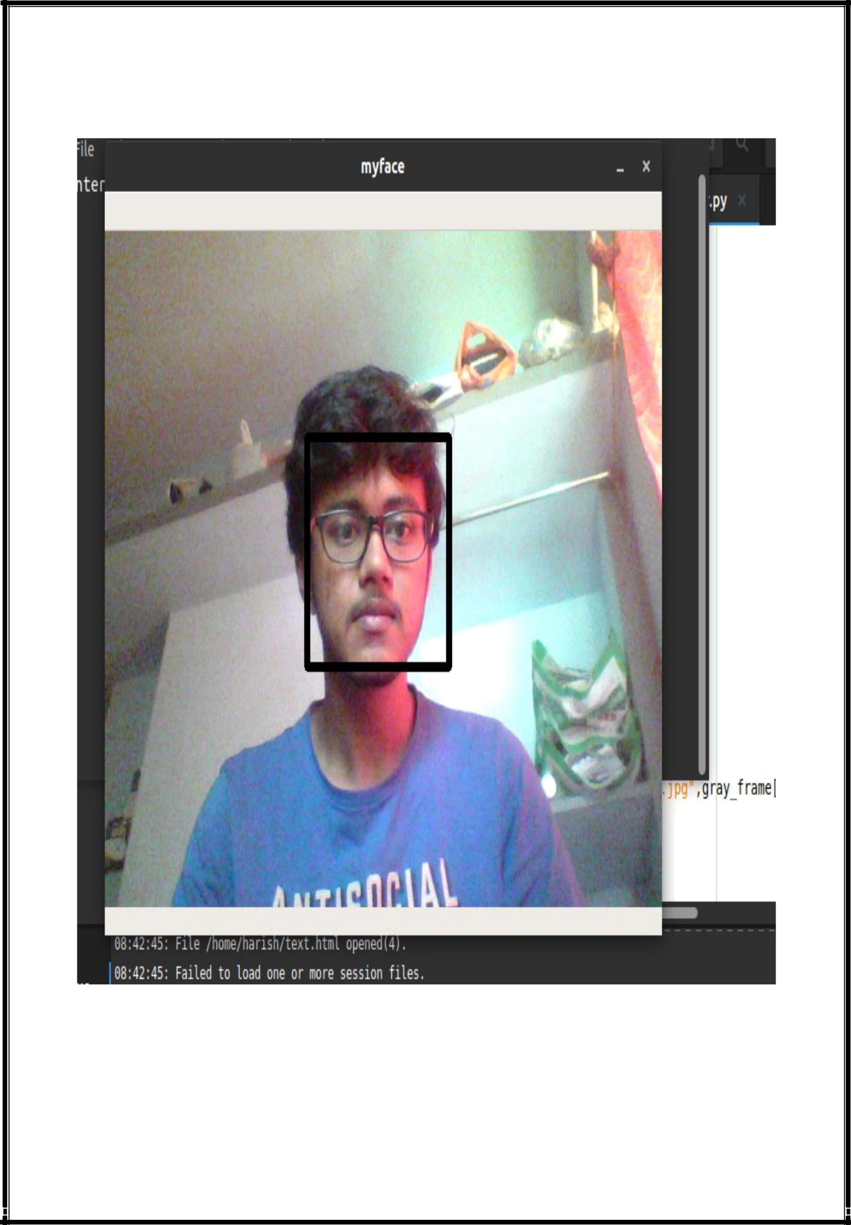
5.5.1 Implementation-Screenshots

Enrollment:

15

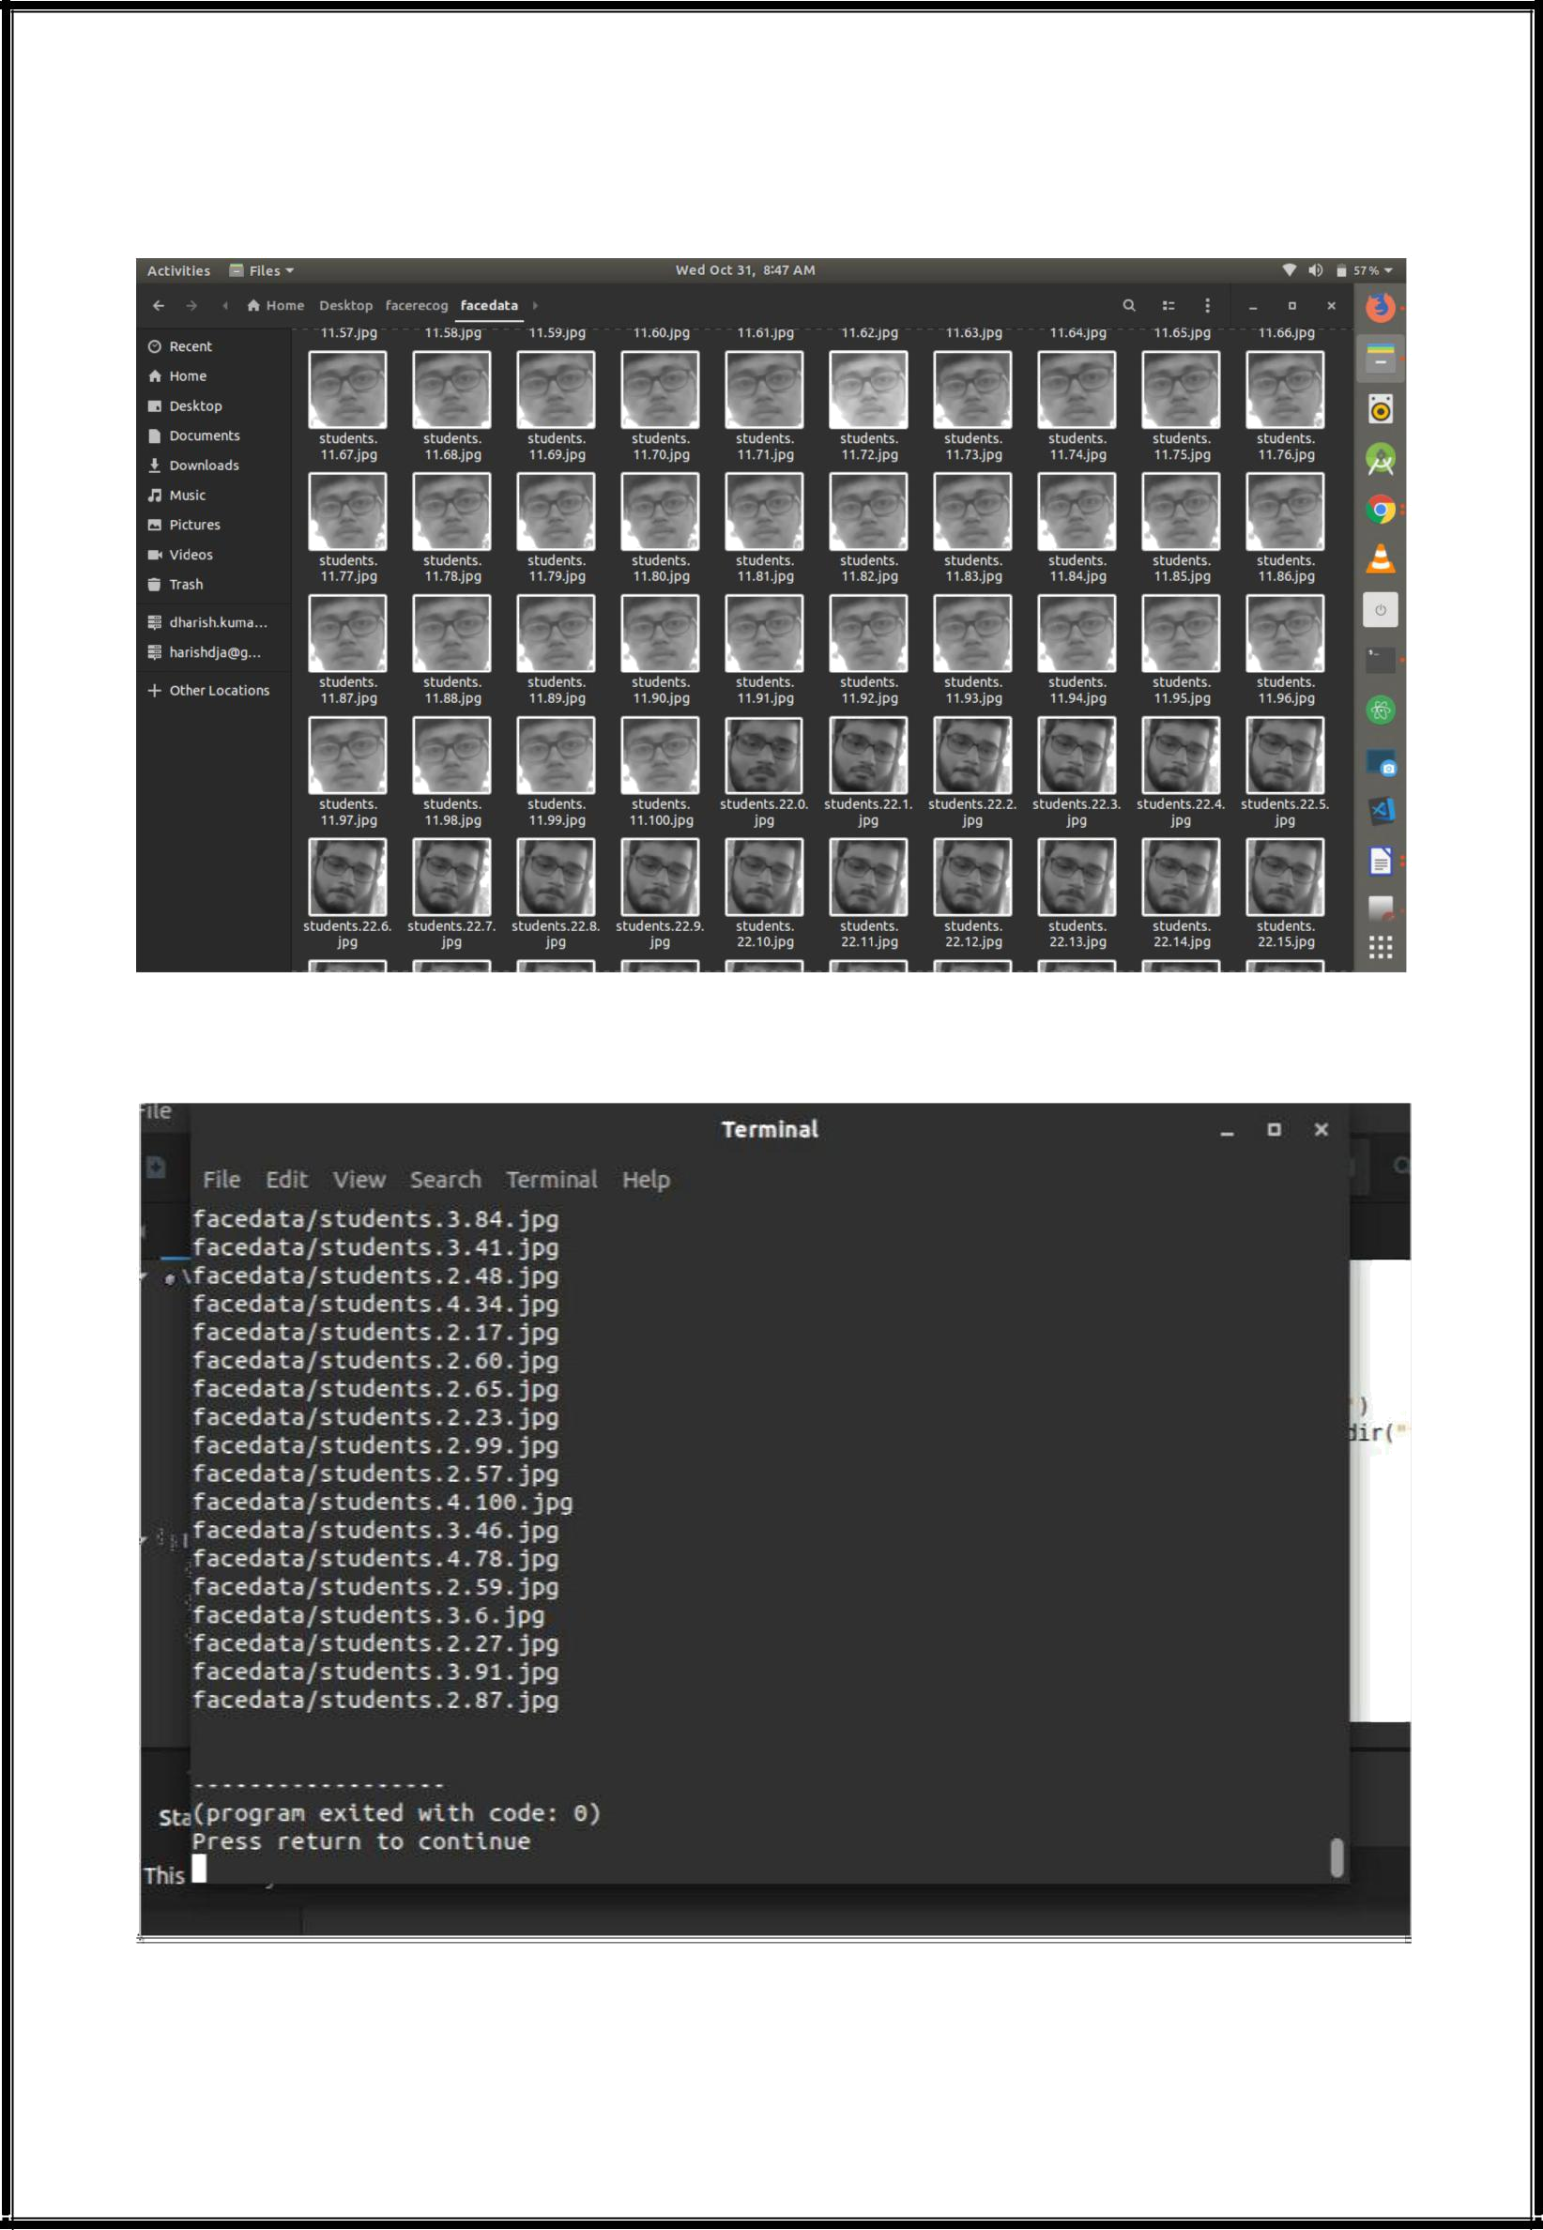

Training

16

Recognition



6.PseudoCode

Begin

Turn on the camera

Start capturing video

Detect face from the captured image

While True (face is not available in the database)

Train face image

Calculate eigen faces

Enter id , name , relationship

Store in the database

While False

Display face is already available in the database

end

Begin

Turn on the camera

Start capturing video

Detect face from the captured image

Train the image

Calculate eigen faces

If calculated value matches with the

database Open telegram

Send message to the house owner’s mobile number (send persons id , name , relationship)

If not available in the database

Send message as unknown face to the house owner’s mobile number

End

Code:

Dataset creator

import cv2

import sqlite

17


camera = cv2.VideoCapture(0)

classifier = cv2.CascadeClassifier('haarcascade_frontalface_default.xml')

def insertOrUpdate(name,regno,relationship):

db = sqlite3.connect('mydbb')

cursor = db.cursor()

cursor.execute('''CREATE TABLE IF NOT EXISTS familydata(name TEXT, ID TEXT,relationship TEXT)''')

cursor.execute('''INSERT INTO familydata VALUES(?,?,?)''', (name,regno,relationship))

print('User inserted')

db.commit()

db.close()

regno = input("Enter the ID no:"); name=input("Enter the name:"); relationship=input("Enter the relationship:"); insertOrUpdate(name,regno,relationship)

i=0

while True:

ret, frame = camera.read()

gray_frame = cv2.cvtColor(frame,cv2.COLOR_BGR2GRAY)

face = classifier.detectMultiScale(gray_frame,1.3,5)

for x,y,w,h in face:

cv2.rectangle(frame,(x,y),(x+w,y+h),(0,0,0),5)

cv2.imshow("myface", frame)

cv2.imwrite("facedata/students."+str(regno)+"."+str(i)+".jpg",gray_frame[y:y+h ,x:x+w])

i = i+1

if cv2.waitKey(1) & 0xFF == ord('q'):

break

elif i>100:

break

18

camera.release()

cv2.destroyAllWindows()

trainer

import os

import cv2

import numpy as np

recognizer = cv2.face.LBPHFaceRecognizer_create()

classifier = cv2.CascadeClassifier('haarcascade_frontalface_default.xml') imagepaths = [os.path.join("facedata",filename) for filename in os.listdir("facedata")]

samples = []

Ids = []

for imagepath in imagepaths:

imgarray = cv2.imread(imagepath,0)

print(imagepath)

Id = int(os.path.split(imagepath)[-1].split(".")[1])

samples.append(imgarray)

Ids.append(Id)

recognizer.train(samples,np.array(Ids))

recognizer.write("trainer.yml")

face recognizer

import telegram

from io import BytesIO

import cv2

import numpy as np

import sqlite3

import telegram

face_classifier = cv2.CascadeClassifier('haarcascade_frontalface_default.xml')

camera = cv2.VideoCapture(0)

19


recognizer = cv2.face.LBPHFaceRecognizer_create()

recognizer.read('trainer.yml')

auth_token = '417489646:AAG0ZJ09qVJhykNOyHrLb9wPdg_iGCYekaM' bot = telegram.Bot(token=auth_token) admin = bot.get_me()

channel_id ='@gotnotf'

i=0

while True:

ret, frame = camera.read()

gray_frame = cv2.cvtColor(frame,cv2.COLOR_BGR2GRAY)

face = face_classifier.detectMultiScale(gray_frame,1.3,5)

ig=BytesIO(frame)

for x,y,w,h in face:

cv2.rectangle(frame,(x,y),(x+w,y+h),(0,0,0),10)

faceid, confi = recognizer.predict(gray_frame[y:y+h,x:x+w])

print(faceid, " ", confi)

conn = sqlite3.connect('mydbb')

cur = conn.cursor()

faceid=str(faceid)

cur.execute("SELECT name,relationship FROM familydata WHERE ID=?", (faceid,))

rows = cur.fetchone()

cv2.putText(frame,rows[0],(x,y-

5),cv2.FONT_HERSHEY_COMPLEX_SMALL,3,(255,255,255),10)

big="your"+rows[1]

bot.sendMessage(chat_id=channel_id,text=big)if i==0:

cv2.imwrite("1"+"."+"jpg",frame)

bot.send_photo(chat_id=channel_id,photo=open('1.jpg', 'rb'))

cv2.imshow('my face',frame)

k = cv2.waitKey(1)

if k==ord('q'):

break

camera.release()

cv2.destroyAllWindows()

20


7.RESULTS

In order to test and validate the proposed face recognition security system, a GUI implementation of the algorithm was applied using Python. The database was created and accessed by the software during the processing of the input image. This system is a real-time face recognition system that reads a real-time video from the camera connected to the computer running the software, takes an image from this video, processes it to detect any human face presented in front of the camera, and then recognizes the face using a set of face images in a database. This system was tested on several cases, and it achieved a face detection accuracy of 98% and a face recognition accuracy of 90%.

8.CONCLUSION:

It is our opinion that in face recognition is an exciting area for many years to come and will keep many scientists and engineers busy. In this project we have given concepts of face recognition methods such as train and recognize faces of individuals and implement acknowledgement through telegram by creating a bot. The present project can provide the security for house owners in apartments and also separate house’s cameras can implement this system for security.

- REFFERENCES:

  - R. Jafri, H. R. Arabnia, “A Survey of Face Recognition Techniques”, Journal of Information Processing Systems, Vol.5, No.2, June 2009.

  - C. A. Hansen, “Face Recognition”, Institute for Computer Science University of Tromso, Norway.

  - M. D. Kelly. Visual identification of people by computer. PhD thesis, Stanford University, Stanford, CA, USA, 1971.

  - T. Kanade. Computer Recognition of Human Faces, 47, 1977.

21


- W. Zhao, R. Chellappa, P. J. Phillips & A. Rosenfeld, “Face recognitions literature survey”, ACM Computing Surveys, Vol. 35, No. 4, December 2003, pp. 399–458.

- C. Gonzalez, R. E. Woods, S. liddins, "Digital Image processing Using MATLAB".

- S. Suhas, A. Kurhe, Dr.P. Khanale, “Face Recognition Using Principal Component Analysis and Linear Discriminant Analysis on Holistic Approach in Facial Images Database”, IOSR Journal of Engineering e-ISSN: 2250-3021, p-ISSN: 2278-8719, Vol. 2, Issue 12 (Dec. 2012), ||V4||

  - 15-23

- M. A. Turk and A. P. Pentland, "Face Recognition Using Eigenfaces", 1991.

- S. Asadi, Dr. D. V. Subba R. V. Saikrishna, "A Comparative study of Face Recognition with PCA and Cross-Correlation Technique", IJCA(0975-8887), Volume 10- No.8, November 2010.

- E. A. Abusham, A. T. B. Jin, W. E. Kiong, "Face Recognition Based on Nonlinear Feature Approach", American Journal of Applied Sciences, 2008.

- A. Nigam, P. Gupta, "A New Distance Measure for Face Recognition System", 2009 Fifth International Conference on Image and Graphics

22

